**Building a semantic HTML webpage**

1. In this video, we will be building a website and going through the concept of “Semantics of HTML”.
2. Semantic guides our webpage on how the page must be structured and wrapped around.
3. Also, semantics is about how your website looks, is it accessible? and does it look nice for the end user?
4. Header.
5. Nav bar.
6. Main content.
7. Sidebar.
8. Footer.
9. Global attributes are those attributes that can be injected into any element.

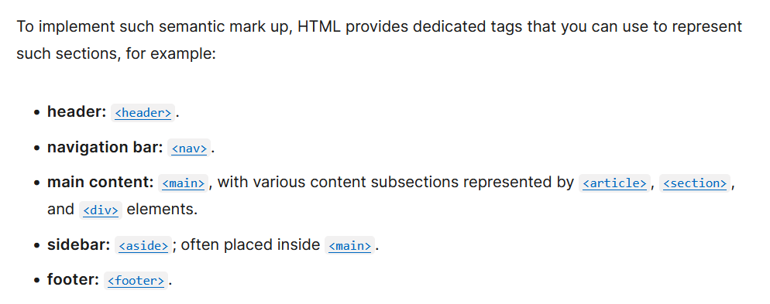

1. Semantics tags do not have a special property like header tag, strong tag etc. they are just used for marking/labelling the content, to give them a appropriate design afterwards.
2. Inside article tag, we can multiple sections or section tags.
3. <hgroup></hgroup> tag is used to group two or more headings together. It is useful when we want to apply same CSS style for two or more headings.

